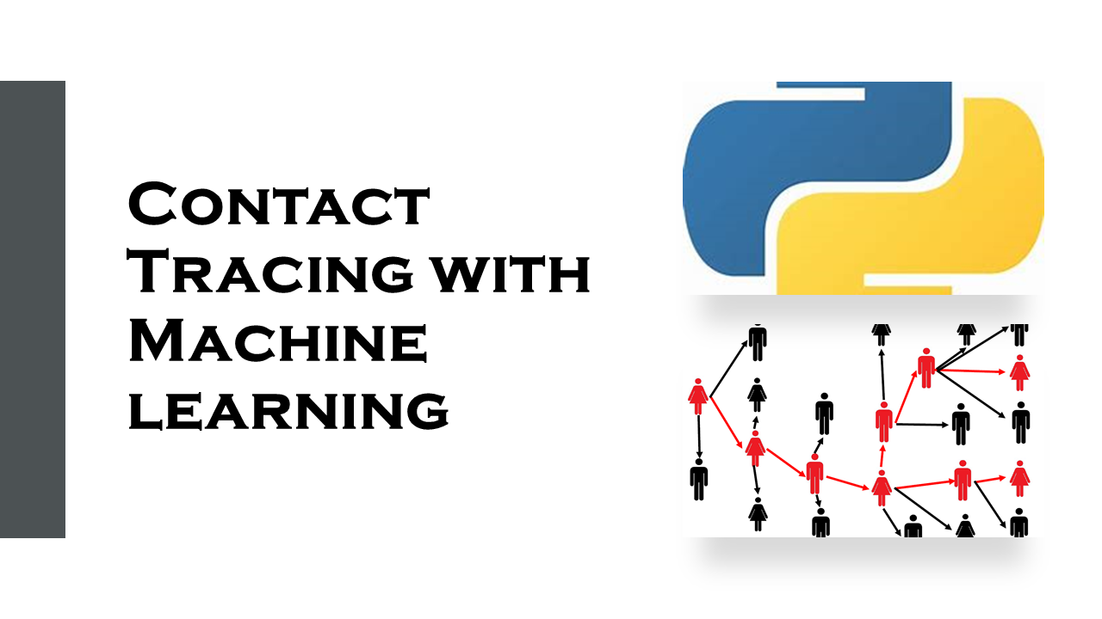
objective:
Contact tracing is a process used by public health officials to identify and monitor the contacts of people who have been infected with a contagious disease. This helps to prevent the spread of the disease by identifying and quarantining people who may have been exposed.
Contact tracing is especially important for diseases that have a long incubation period, such as COVID-19, where people can be infectious before they develop symptoms.
Attribute Information:
The following are some descriptions of the data points in the context of contact tracking with ML:
- ID: This data point uniquely identifies each individual in the dataset. It is important to note that this ID should not be personally identifiable information (PII), such as a name or phone number.
- Timestamp: This data point indicates the time at which a contact event occurred. It is important to have accurate timestamps in order to track the spread of a disease or infection.
- Latitude: This data point indicates the latitude of the location where a contact event occurred.
- Longitude: This data point indicates the longitude of the location where a contact event occurred.
These data points can be used to train a machine learning model to predict the likelihood of contact between two individuals, given their spatial and temporal proximity. This information can then be used to identify individuals who are at risk of exposure to a disease or infection, and to develop interventions to prevent the spread of the disease.
Here are some examples of how these data points could be used in a contact tracking with ML project:
- Identify individuals who have been in contact with a known infected person: By comparing the ID, timestamp, latitude, and longitude of a known infected person to the ID, timestamp, latitude, and longitude of all other individuals in the dataset, it is possible to identify individuals who have been in contact with the infected person.
- Predict the likelihood of contact between two individuals: By using the data points to train a machine learning model, it is possible to predict the likelihood of contact between two individuals, given their spatial and temporal proximity. This information can then be used to identify individuals who are at risk of exposure to a disease or infection.
- Develop interventions to prevent the spread of a disease: By understanding the patterns of contact between individuals, it is possible to develop interventions to prevent the spread of a disease. For example, if it is known that a disease is spread through close contact, then interventions such as social distancing or quarantine can be implemented to reduce the risk of transmission.
It is important to note that contact tracking with ML is a complex and sensitive topic. There are a number of ethical and privacy considerations that need to be addressed when using this technology. For example, it is important to ensure that the data collected is protected and that individuals are informed about how their data is being used.
Exploratory data analysis:
=>In these project we draw a plot for the longitude and longitude at each every id
=>we can draw another graph for boxplot for the id and latitude
=> we can draw one more graph of boxplot for the id and latitude
Hardware requirements:
• CPU: A modern multicore processor, such as an Intel Core i5 or i7, is recommended
for training and deploying machine learning models.
• RAM: A minimum of 8GB of RAM is recommended, although more may be required
for larger datasets.
• GPU: A powerful graphics processing unit (GPU) can significantly speed up training
and inference of deep learning models. Nvidia GPUs are the most commonly used for
machine learning tasks.
• Storage: A large amount of storage is required to store and process large datasets.
Solid-state drives (SSDs) are recommended for fast access to data.
Software requirements:
• Operating System: Most machine learning frameworks are compatible with popular
operating systems such as Windows, macOS, and Linux.
• Python: Python is the most commonly used programming language for machine
learning, and most machine learning frameworks are built using Python.
• Machine Learning Frameworks: There are many machine learning frameworks
available, such as TensorFlow, PyTorch, Keras, and scikit-learn. These frameworks
provide tools and APIs for building, training, and deploying machine learning
models.
• Development Tools: IDEs such as PyCharm, Jupyter Notebook, and Visual Studio
Code are commonly used for machine learning development.
• Libraries: Libraries such as NumPy, Pandas, and Matplotlib,tensorflow ,keras are commonly used for data manipulation, analysis, and visualisation, and artificial neural network
In summary, to get started with your project, you will need a computer with a powerful CPU
and GPU, a minimum of 8GB of RAM, and large storage capacity. You will also need to
install Python and various machine learning libraries and frameworks.
Existing system:
Traditional contact tracing is a labour-intensive process that involves interviewing infected people to identify their close contacts. These contacts are then notified and advised to monitor themselves for symptoms and get tested if necessary.
However, traditional contact tracing can be challenging to implement effectively, especially during a pandemic when there are a large number of cases. It can also be difficult to identify all of an infected person's contacts, especially if they have been active in social settings.
Proposed system :
Machine learning (ML) can be used to improve the efficiency and accuracy of contact tracing. ML-based systems can use data from a variety of sources, such as mobile phone location data, social media data, and public health records, to identify and track the contacts of infected people.
One example of an ML-based contact tracing system is the MIT-developed SafePaths app. SafePaths uses Bluetooth to track the contacts of users who have opted in to the app. If a user tests positive for COVID-19, the app can notify their recent contacts so that they can get tested and quarantine themselves if necessary.
Benefits of using ML for contact tracing
ML-based contact tracing systems have a number of benefits over traditional contact tracing methods:
- They can be more efficient and scalable, as they can process large amounts of data quickly and automatically.
- They can be more accurate, as they can use data from a variety of sources to identify and track contacts.
- They can be more privacy-preserving, as they can be designed to minimise the collection and sharing of personal data.
Challenges of using ML for contact tracing
One challenge of using ML for contact tracing is developing ML models that are accurate and reliable. ML models need to be trained on large amounts of data, and it can be difficult to obtain this data without compromising user privacy.
Another challenge is ensuring that ML-based contact tracing systems are fair and equitable. It is important to ensure that these systems do not disproportionately disadvantage certain groups of people.
Architectural diagram:
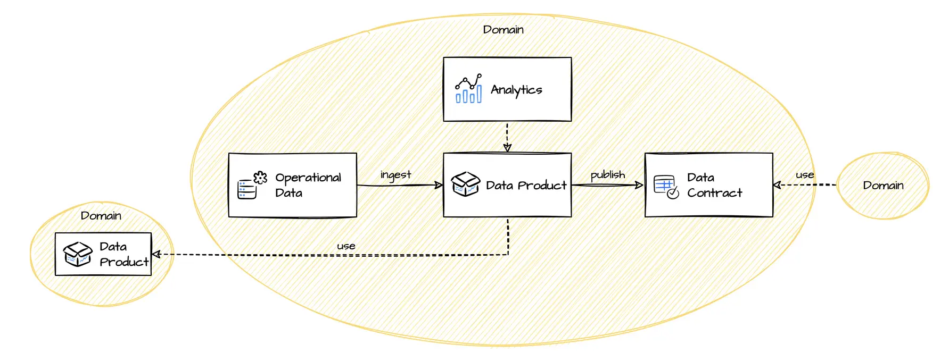
Conclusion:
Machine learning (ML) is a powerful tool that can be used to improve the efficiency and accuracy of contact tracing. ML-based contact tracing systems can use data from a variety of sources, such as mobile phone location data, social media data, and public health records, to identify and track the contacts of infected people.
ML-based contact tracing systems have a number of benefits over traditional contact tracing methods:
- They can be more efficient and scalable, as they can process large amounts of data quickly and automatically.
- They can be more accurate, as they can use data from a variety of sources to identify and track contacts.
- They can be more privacy-preserving, as they can be designed to minimise the collection and sharing of personal data.
However, there are also some challenges to using ML for contact tracing. One challenge is developing ML models that are accurate and reliable. ML models need to be trained on large amounts of data, and it can be difficult to obtain this data without compromising user privacy.
Another challenge is ensuring that ML-based contact tracing systems are fair and equitable. It is important to ensure that these systems do not disproportionately disadvantage certain groups of people.
Despite these challenges, ML has the potential to revolutionise contact tracing, making it more efficient, accurate, and privacy-preserving. As ML technology continues to develop, we can expect to see ML-based contact tracing systems become more widely deployed.
In addition to the above, I would like to add that ML-based contact tracing systems can be used to develop new insights into the spread of disease. For example, ML models can be used to identify patterns in the movement of people and to predict where outbreaks are likely to occur. This information can be used to develop more effective public health interventions.
Overall, I believe that ML has the potential to play a significant role in the future of contact tracing and public health.

